Mutchumari Chandrasekhar Reddy- AP25110010976

1.MST implementation using Kruskal's Algorithm.
Program:
#include<stdio.h>
int parent[20];
int find(int i)
{
while(parent[i]!=i)
i=parent[i];
return i;
}
void unite(int i,int j)
{
int a=find(i),b=find(j);
parent[a]=b;
}
int main()
{
int n,e,i,j,u,v,w,mincost=0,count=0;
int edge[50][3];
printf("Enter number of vertices: ");
scanf("%d",&n);
printf("Enter number of edges: ");
scanf("%d",&e);
printf("Enter edges (u v w):\n");
for(i=0;i<e;i++)
scanf("%d%d%d",&edge[i][0],&edge[i][1],&edge[i][2]);
for(i=0;i<n;i++)
parent[i]=i;
for(i=0;i<e-1;i++)
for(j=0;j<e-i-1;j++)
if(edge[j][2]>edge[j+1][2])
{
int t0=edge[j][0],t1=edge[j][1],t2=edge[j][2];
edge[j][0]=edge[j+1][0];
edge[j][1]=edge[j+1][1];
edge[j][2]=edge[j+1][2];
edge[j+1][0]=t0;
edge[j+1][1]=t1;
edge[j+1][2]=t2;
}
printf("Edges in MST:\n");
for(i=0;i<e&&count<n-1;i++)
{
u=edge[i][0];
v=edge[i][1];
w=edge[i][2];
if(find(u)!=find(v))
{
unite(u,v);
printf("%d - %d = %d\n",u,v,w);
mincost+=w;
count++;
}
}
printf("Minimum Cost = %d",mincost);
return 0;
}
Terminal Process:
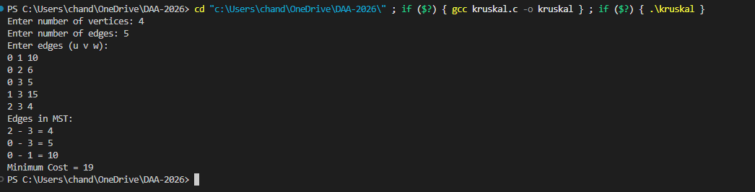
2.MST implementation using Prim's Algorithm.
Program:
#include<stdio.h>
#define INF 9999
int main()
{
int n,i,j,u,v,min,mincost=0,count=0;
int cost[20][20],visited[20]={0};
printf("Enter number of vertices: ");
scanf("%d",&n);
printf("Enter cost adjacency matrix:\n");
for(i=0;i<n;i++)
for(j=0;j<n;j++)
scanf("%d",&cost[i][j]);
visited[0]=1;
printf("Edges in MST:\n");
while(count<n-1)
{
min=INF;
u=v=-1;
for(i=0;i<n;i++)
if(visited[i])
for(j=0;j<n;j++)
if(!visited[j]&&cost[i][j]<min&&cost[i][j]!=0)
{
min=cost[i][j];
u=i;
v=j;
}
if(u==-1)
break;
printf("%d - %d = %d\n",u,v,min);
mincost+=min;
visited[v]=1;
count++;
}
printf("Minimum Cost = %d",mincost);
return 0;
}
Terminal Process:
